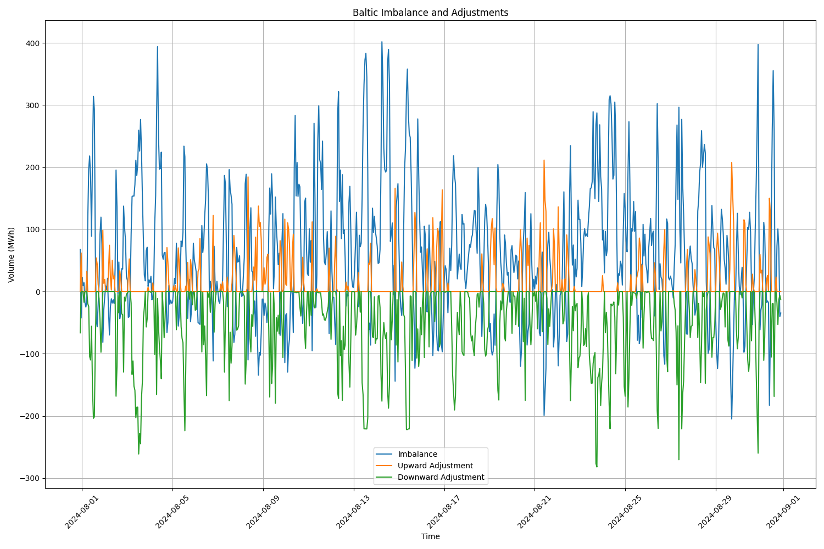

The graph shows the Baltic region's electric energy imbalances, along with adjustments made to compensate for these imbalances.

An upward adjustment occurs when demand exceeds supply, so to restore balance, power generation is increased and/or consumption is decreased.

A downward adjustment occurs when supply exceeds demand, and to balance it, generation is reduced or consumption is increased. In the generated graph, the downward adjustment is inverted on the y-axis for clarity.

Based on this logic we can conclude:

* If the imbalance is greater than 0 and the downward adjustment is greater than 0 (same direction, but in the graph, they appear on opposite sides), the adjustment is accurate.
* If imbalance is less than 0 and upward adjustment is bigger than 0 (mirrored) then the adjustment is accurate

Based on this knowledge i got regulation actions were correct ~80% of the time which means prediction work pretty well but could be better.

Another way to look at it is through mirroring, if imbalance and adjustments are mirrored the results are accurate.   
In conclusion power grid demand is complex and variable so it needs good prediction model for accurate adjustments.